**Bipolar Junction Transistor**

* Bipolar junction transistors are a particular kind of transistor that are used as current controllers to increase output current using input current.
* Bipolar signifies that the current here runs as a result of both majority and minority carriers, as the name would imply.
* The device has three terminals (emitter, base, and collector).
* The largest zone is the collector, followed by the emitter and the base, which are the thinnest regions (collector > emitter > base).
* This is because the base is the thinnest as it must make the holes or electrons go from it, whereas the collector must accept the electrons or holes that are emitted from the emitter.
* **Construction of BJT:-**

Two diodes can be used to construct it, and both diodes must be connected in the circuit so that they are in series and facing in the opposite directions (i.e. the n side of diodes are combined or p side of diodes are combined). Therefore, a bjt will form.

**SYMBOL OF BJT:-**

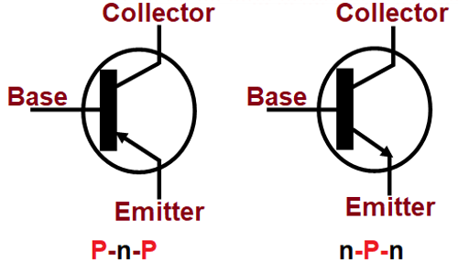

IN NPN THE CURRENT FLOWS FROM EMIITER TO BASE HENCE ARROW IS IN OUTWARD DIRECTION.

IN PNP THE CURRENT FLOWS FROM EMITTER TO BASE HENCE ARROW IS IN INWARD DIRECTION.

**Working principal:-**

The first junction that is the emitter base region should be forward bias and the second junction that is base collector that should be reverse bias.

**Types of bjt :-**

* There are two types of bjt :-
* NPN bipolar junction transistor
* PNP bipolar junction transistor

**BJT CHARACTERISTICS**

BJT characteristics can be broken down into:

* **Input characteristics:** How IB changes with VBE, at constant VCE[2](https://blog.mbedded.ninja/electronics/components/transistors/bipolar-junction-transistors-bjts/" \l "fn:2).
* **Transfer characteristics:** How IC changes with IB, at constant VCE.
* **Output characteristics:** How IC changes with VCE, at constant IB.
* **Mutual characteristics:** How IC  changes with VBE

**Output Characteristics**

The characteristic output curve for a BJT shows show the collector current IC changes as the collector-emitter voltage VCE changes, at a fixed base current IB. This curve is shown for a number of base currents to cover a range of operation points, and generally you can interpolate between the curves for your specific base current if needed.

The below figure shows the simulated output transfer characteristics for the popular 2N2222 BJT. IC  is plotted against VCE  for a range of base currents IB  varying from 0 to 5 mA: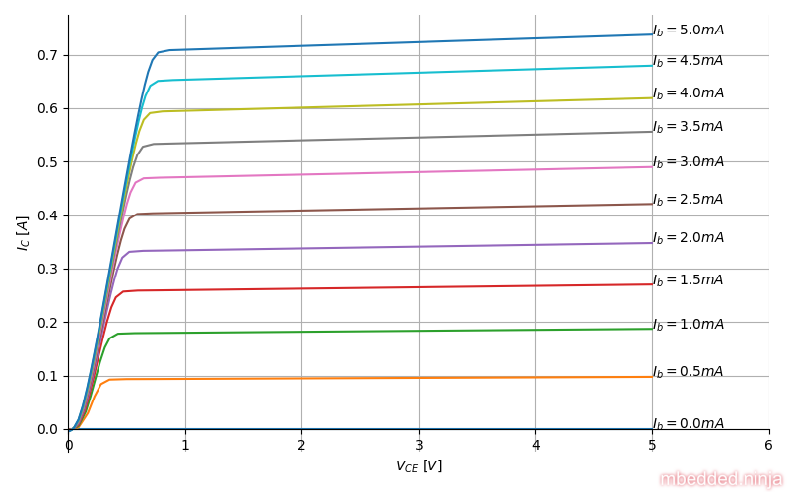

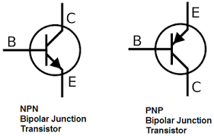

* **NPN bipolar junction transistor:-**
* As the name suggests it is the type of transistor where the p side of both the diodes is combined and now it is a common region for both the diodes.

**Working of NPN :** **-**

* 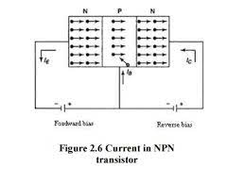By connecting the negative side of the battery to the emitter and the positive side to the base, the emitter and base area is made forward biassed. In the second junction, the positive side of another battery is connected to the collector, and the negative side is connected to the base. As a result of the electrons of the battery and the emitter repelling one another, the electrons move from the emitter to the base. Because only 5% of the electrons that flow from the base to the collector are recombined, the remaining 95% arrive at the collector, causing the IE current to generate. As a result, the current becomes increasingly amplified because the electrons are continually released.

* **CURRENT EQUATION:-**

BY KCL=

IE =IC+IB

* **PNP bipolar junction transistor:-**
* As the name suggests it is the type of transistor where the n side of both the diodes is combined and now it is a common region for both the diodes.

**8Working of PNP:-**

* By connecting the positive side of the battery to the emitter and the negative side to the base, the emitter and base area is made forward biassed. In the second junction, the negative side of another battery is connected to the collector, and the positive side is connected to the base. As a result of the holes of the battery and the emitter repelling one another, the holes flow from the emitter to the base. The outcome is the formation of the IE current, which occurs when the holes migrate from the base to the collector. Only 5% of the holes will now recombine, leaving the remaining 95% to reach the collector, resulting in the formation of the IC current, which causes the current to become further magnified.

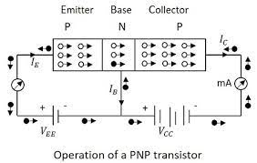

* **CURRENT EQUATION:-**

BY KCL= IE =IC+IB

* **Application of bjt**

1. Preferred transistor for the logic gate.
2. Can be used as amplifiers.
3. Can be used in ossilator circuits.
4. Preferred in the multi-vibrator circuits.
5. Can be used in clipping and time delay circuits.
6. Used as switching circuits.

========== END OF DOCUMENT ==========